0. Connecting to Virtual machine:
Configure OpenVPN:
i. Navigate to the folder where the “client.ovpn” file is present and open terminal.

ii. execute the command: sudo openvpn –config client.ovpn
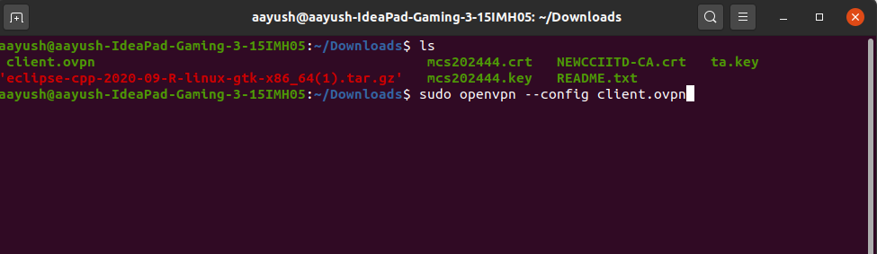

iii. Enter your credentials for OpenVPN

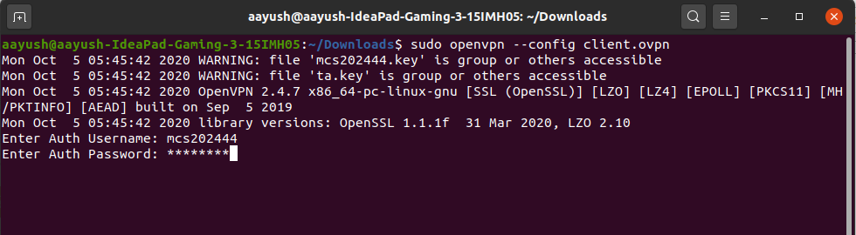
iv. Connection to VPN is established

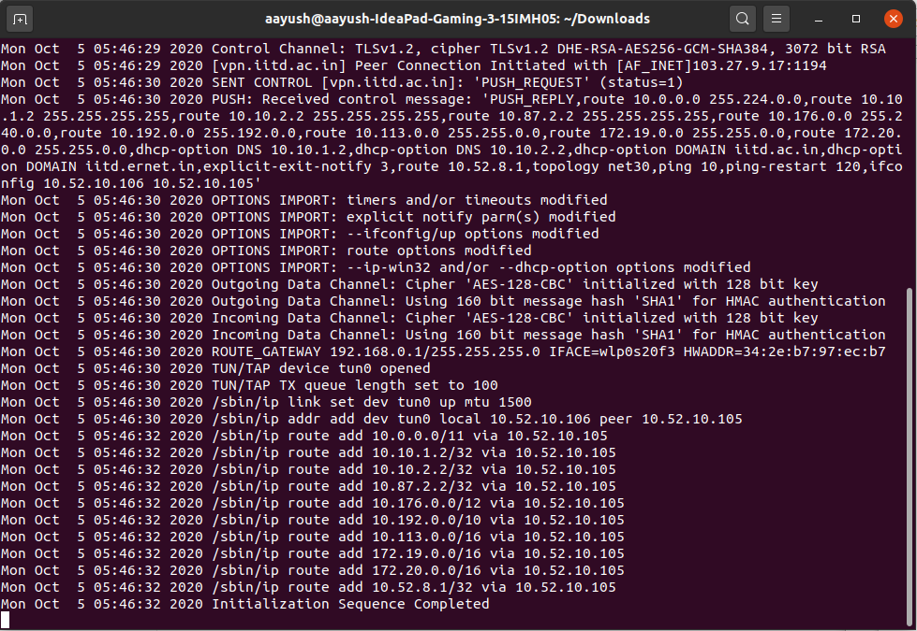
Connect to VM:
i. execute ssh command to connect. It will promt to enter credentials for VM.

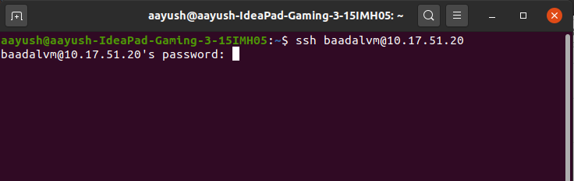
ii. Connection to VM is eastablished.

1. Configured Ubuntu for the libraries and frameworks that we require(e.g sublime/eclipse etc)
i. Download eclipse for your machine from http://www.eclipse.org/downloads/packages/
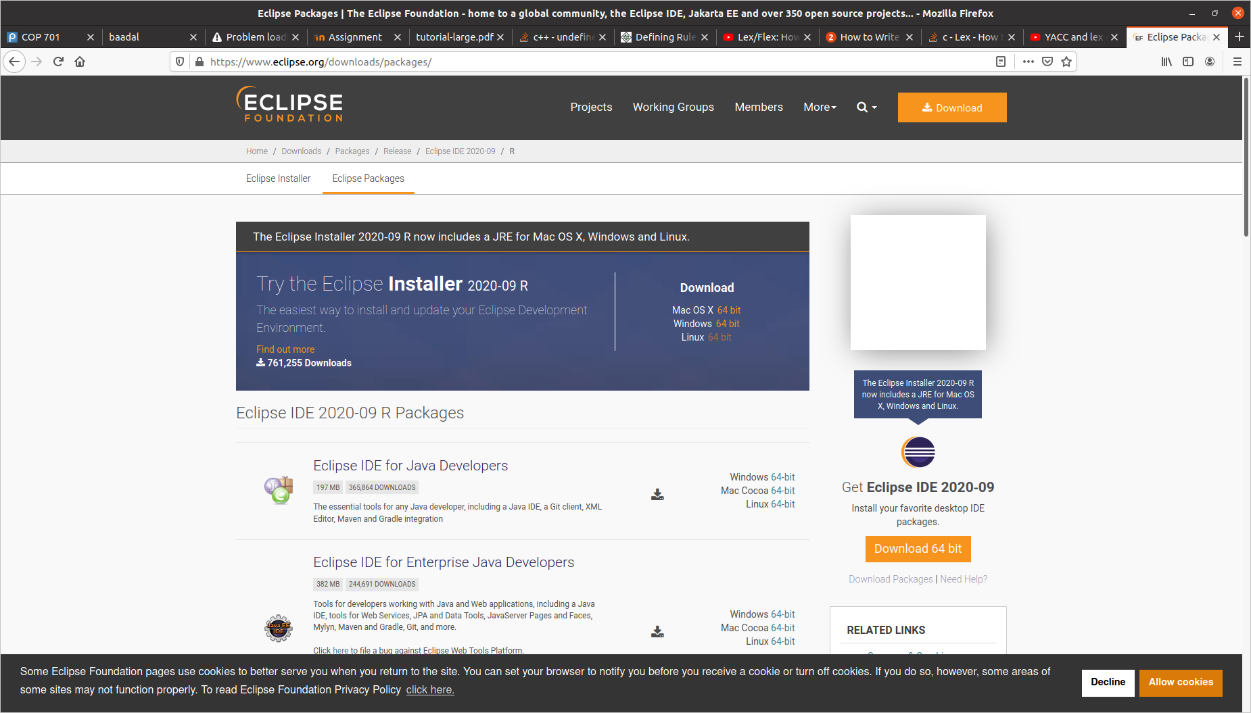

ii. Extract the downloaded file by navigating to the folder and executing the following command:
tar -xvzf eclipse-cpp-2020-09-R-linux-gtk-x86_64.tar.gz
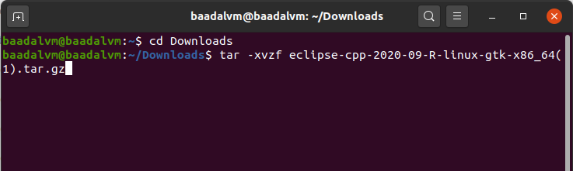

iii. Run Eclipse from extracted folder.
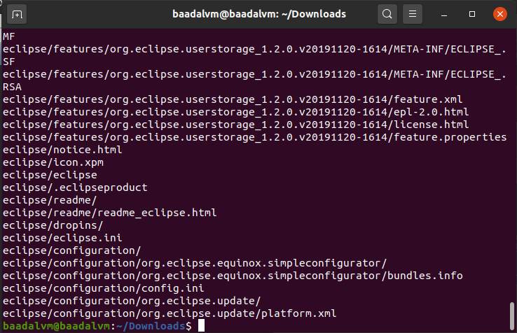
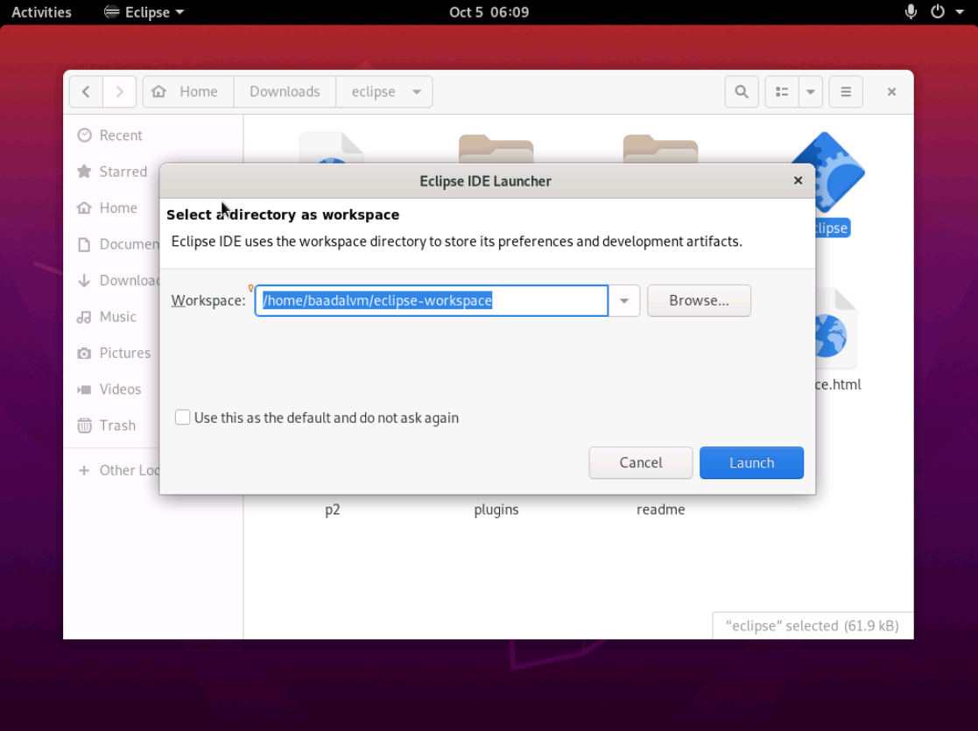

2. Installed SVN and familiarized yourself --- submit a history
Step i: Install Apache by executing the following commands:
sudo apt update
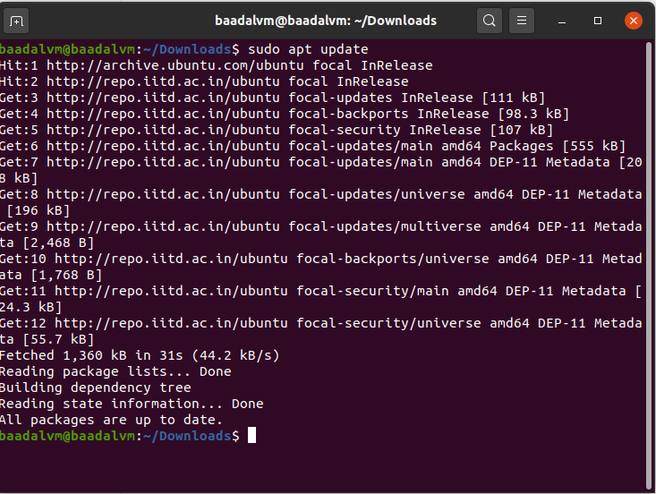
sudo apt install apache2 apache2-utils
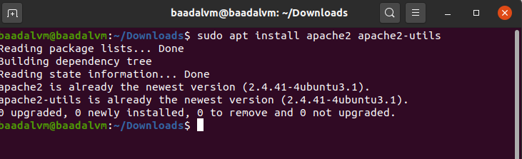
Step ii: After installing Apache2 start and enable it by executing following commands:
sudo systemctl start apache2.service
sudo systemctl enable apache2.service
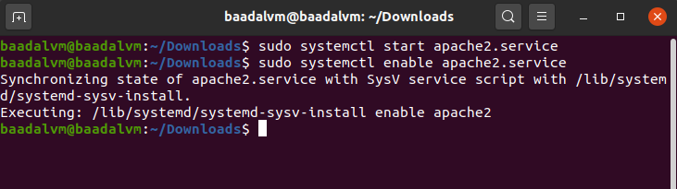

Step iii. Install SVN by executing the following command:
sudo apt-get install subversion libapache2-mod-svn subversion-tools libsvn-dev

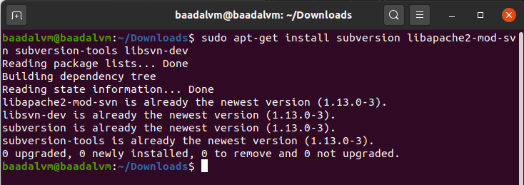
Step iv. Enable Apache2 modules to run SVN by executing following commands:
sudo a2enmod dav
sudo a2enmod dav_svn
sudo service apache2 restart

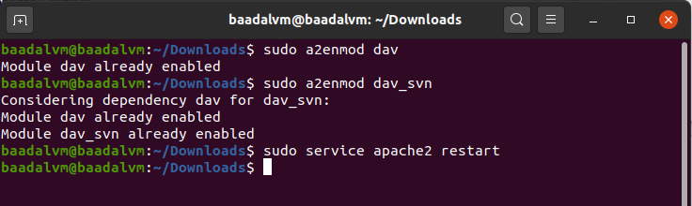
Step v. Configure Apache2 with SVN:
make changes to dav_svn.conf files as follows:

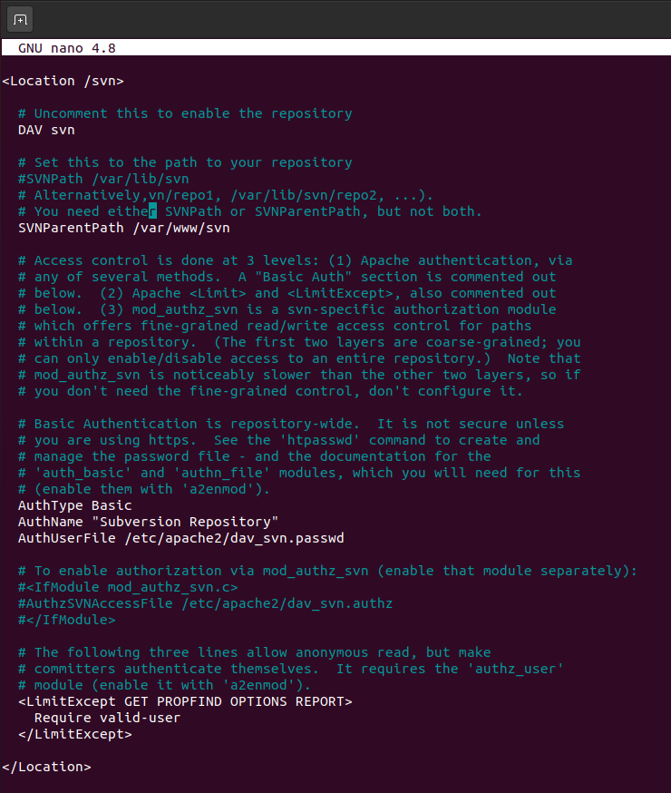

Step vi. Make a repository by executing the following commands:

sudo mkdir /var/www/svn
sudo svnadmin create /var/www/ svn/project
sudo chown -R www-data:ww-data /var/www/svn
sudo chmod -R 775 /var/www/svn

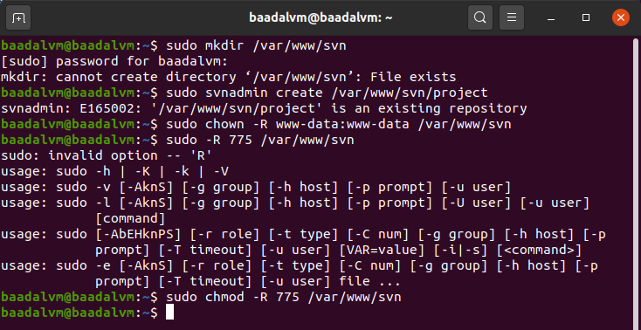
Step vii. Create SVN User Accounts using below caommand and restart Apache:
sudo htpasswd -cm etc/apache2/dav_svn.passwd admin

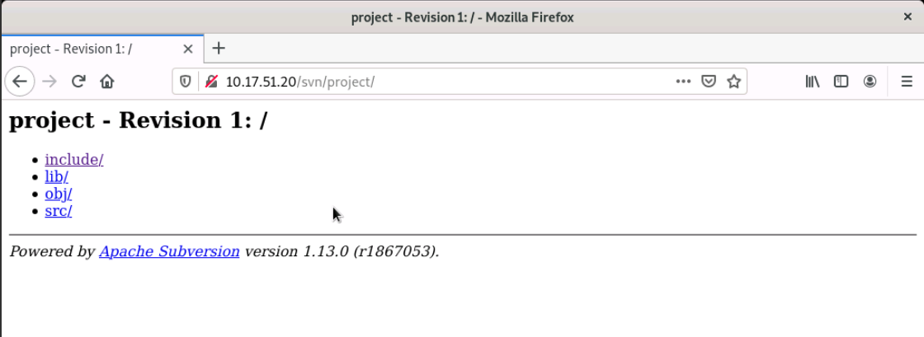

3. Made a template for projects which has the directory structure which you replicate for all assignments
Step i. Create the directories for src, include, lib, obj files.

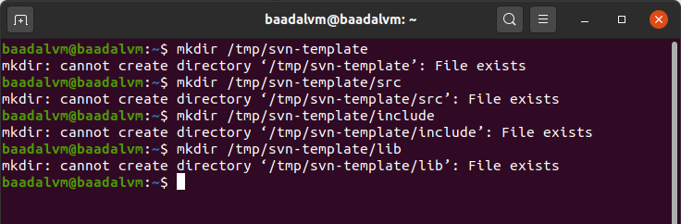
Step ii. Import the directories to project by executing the following command:

sudo svn import -m ‘initial test’ /tmp/svn-template/ http://10.17.51.20/svn/project/

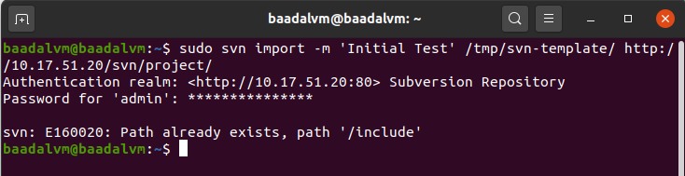
Created Directory structure:
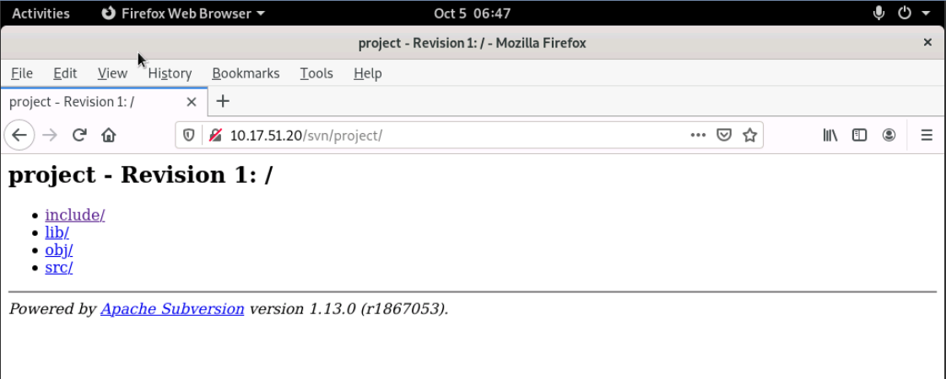

4. Got MAKE to work.
Step i. Create Makefile
vi Makefile and save
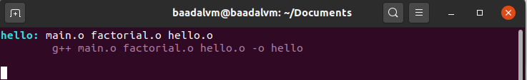
Step ii. Execute the make file using ‘make’ command:
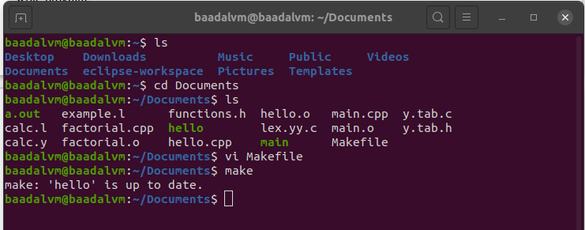
Step iii. Execute the ‘hello’ file generated by ./hello

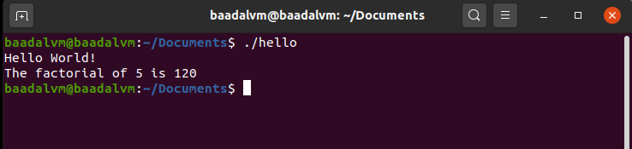

5. Ran some lex and yacc examples:
Step i: Install lex and yacc by executing the following commands:
sudo apt install flex
sudo apt install bison

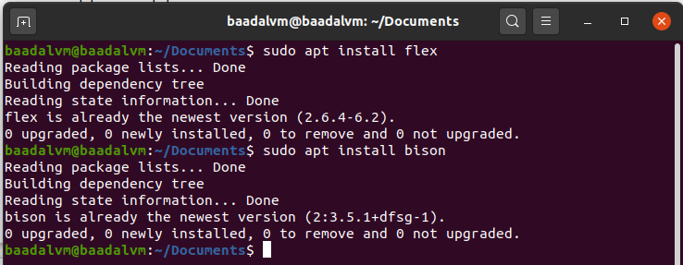
Step ii. FOR LEX: Create a Lex file using vi example.l

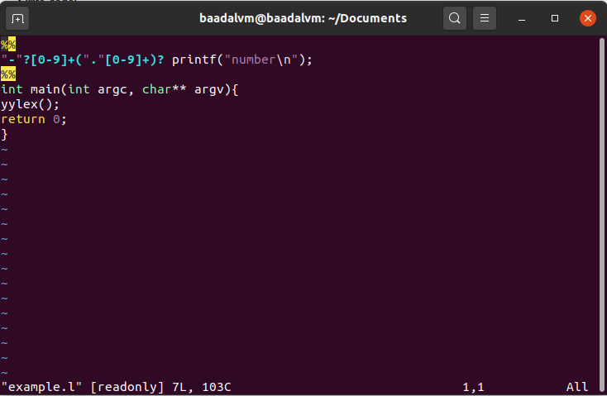
Step iii. Compile and execute it using following commands:
lex example.l //Creates lex.yy.c file
gcc -lfl lex.yy.c //Creates a.out
./a.out

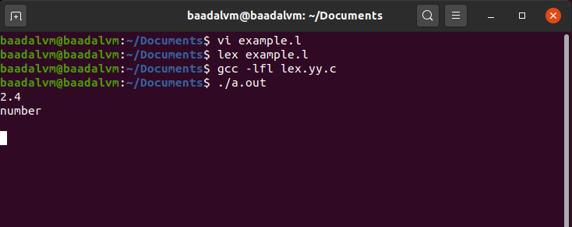
OUTPUT: prints ‘number’ when a floating point number is typed as input

Step iv. FOR YACC: Create a YACC file using vi calc.y and correspong lex file using vi calc.l

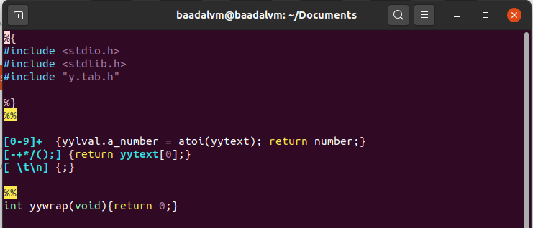
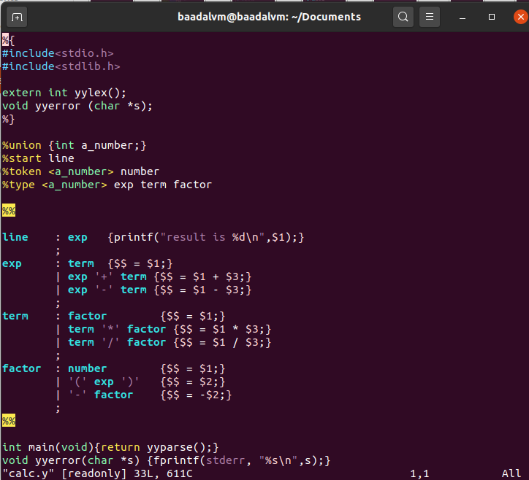

Step v. Comile and execute using the following commands:
yacc -d calc.y
gcc y.tab.c lex.yy.c
./a.out

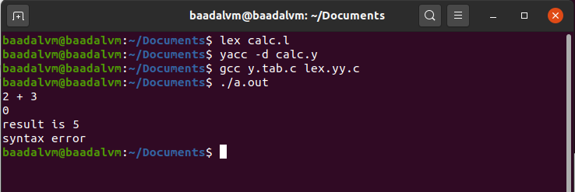
OUTPUT: example of calculator

6. Used GNUplot

Step i: Install GNUPlot using sudo apt-get install gnuplot
Step ii. Launch GNUplot using command ‘gnuplot’.

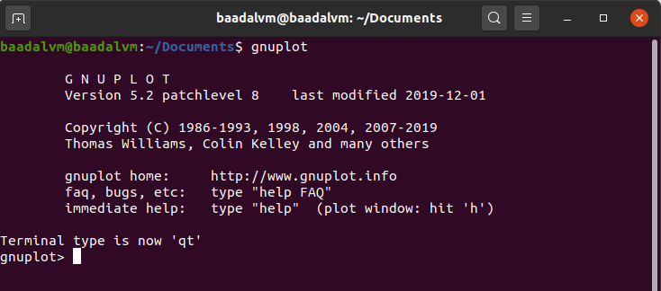
Step iii. To plot a graph for tan(x) execute ‘plot tan(x)

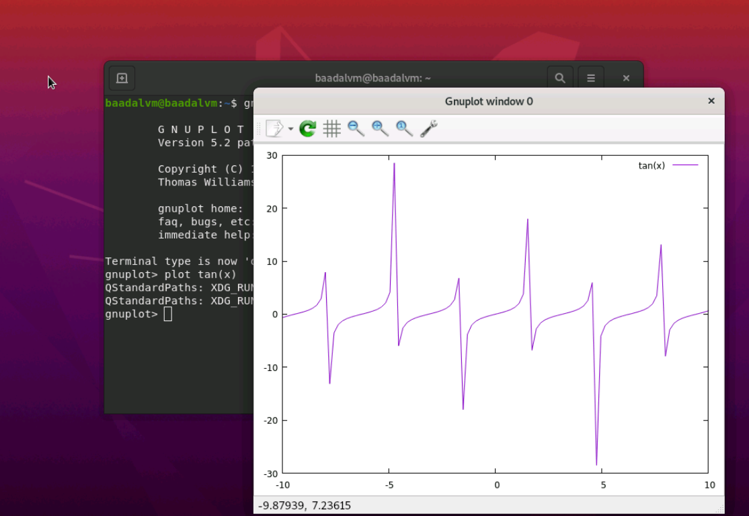

7. Got make to call lex, yacc and gnuplot
(i) LEX:
Step 1: create a makefile as:
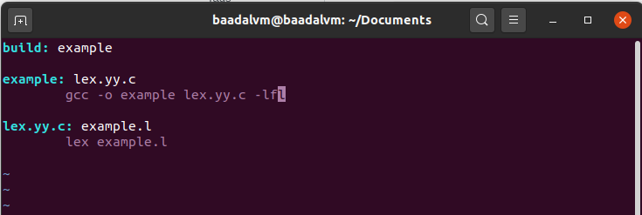
Step 2: run make
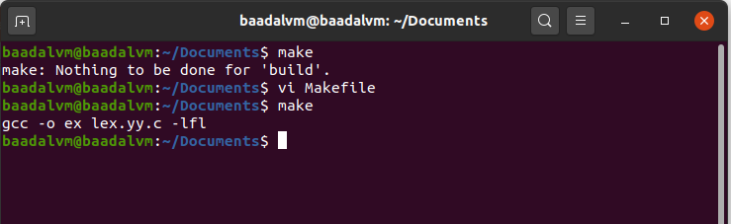
(ii) YACC:
Step 1: create a makefile as:
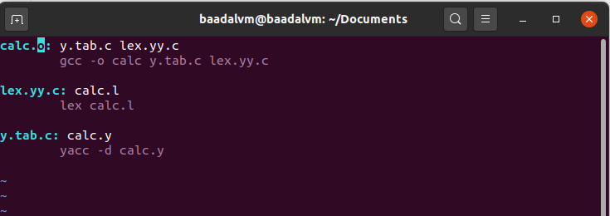
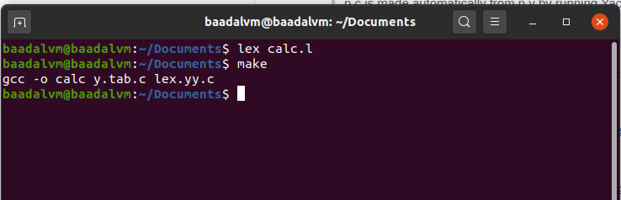
Step2: run make file

